**Solam Jung Rana**

**Lab 6  
Hive Query Language program:**

1. **Top 10 highest paid engineers**

**Query:**   
SELECT DISTINCT job_titles,annual_salary FROM chicago_salary_records WHERE job_titles LIKE '%ENGINEER' ORDER BY annual_salary DESC LIMIT 10;

**Output:**

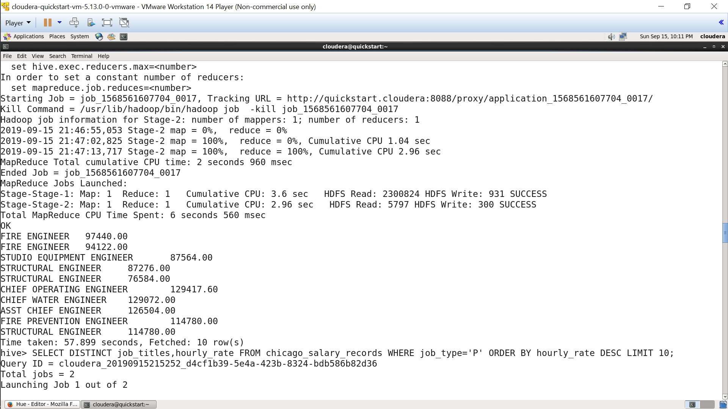

1. **Top 10 highest paid part time job titles**

**Query:**

SELECT DISTINCT job_titles,hourly_rate FROM chicago_salary_records WHERE job_type='P' ORDER BY hourly_rate DESC LIMIT 10;

**Output:**

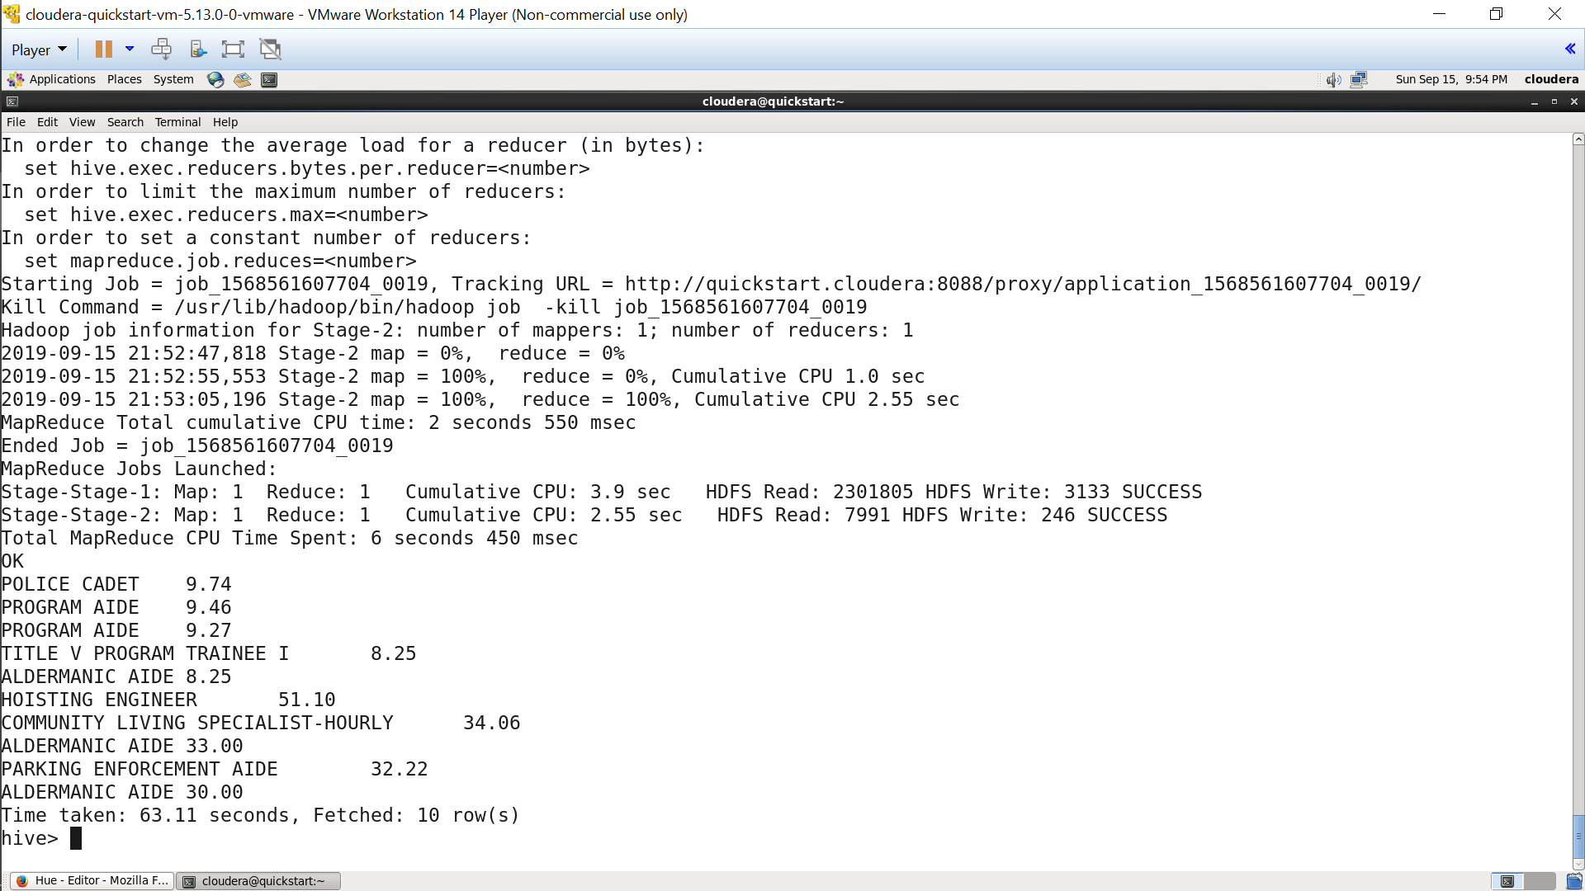

1. **Top 5 Department with highest part time job titles**

**Query:**

SELECT dept, COUNT(1) AS number FROM chicago_salary_records WHERE job_type='P' GROUP BY dept ORDER BY number DESC LIMIT 5;

**Output:**

